
Prostars Weekend Activity Pack

Name:
Age:
School:

Mission Statement

Prostars aspires to develop & improve the delivery of physical literacy, with opportunities for all to compete & participate in PE & School Sport.
We have created a range of Physical Activity Planners for children to complete when they are not in school. Our planners offers a variety of activities your child can complete to help track their progress to leading a healthy lifestyle, being active and to enjoy the holidays!
We hope you enjoy our pack!
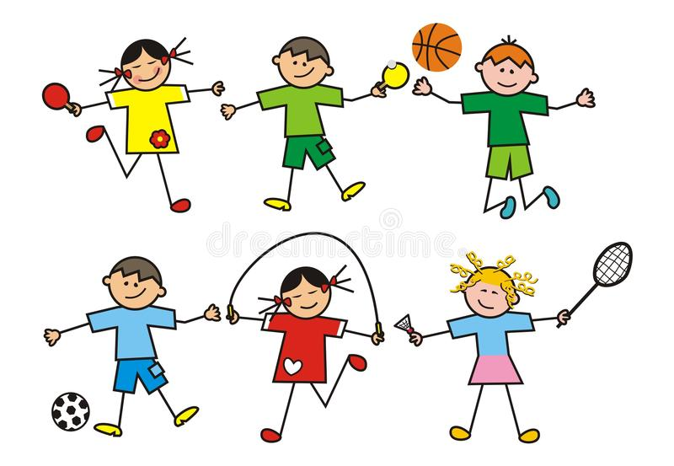

Prostars ‘Going for Gold’ Fitness Challenge

Here is our ‘Going for Gold’ fitness challenge. We at Prostars believe in setting goals and working hard to reach our goals and everybody is different in their goals and objectives.
So, for this challenge we want you to set your goal (Gold) and go for it! Your gold could be our silver challenge, it could be our bronze challenge or the Gold but what you chose is your GOLD.
For each activity you perform for 1 minute in a circuit method, this can be alone or with your family members and you then collect your scores on the scoresheet. The objective is to increase your score each round.
Give it a go, have fun, be active and enjoy moving!
(At the bottom of our pack is a space for you to put your photos of you and your family taking part!)



Prostars ‘Going for Gold’ Fitness Challenge

 | Bronze | Silver | Gold
Burpees | 10 | 15 | 20
Squats | 20 | 25 | 30
Leg Raises | 15 | 20 | 30
Lunges | 20 | 30 | 35
Ab ball | 5 | 10 | 15
Press Ups | 10 | 15 | 25
Speed Bounce | 20 | 30 | 35

Go for YOUR gold!!



Burpees

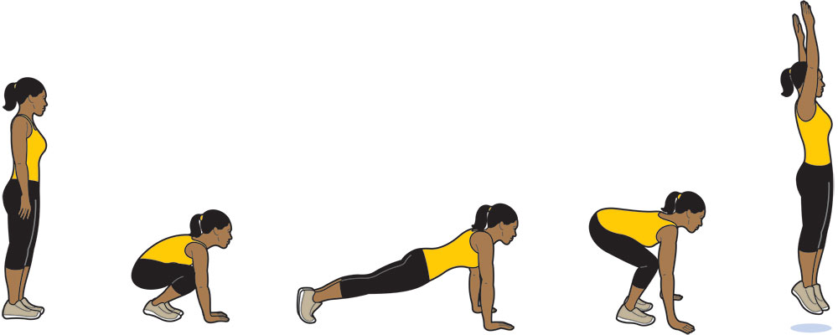

Squats

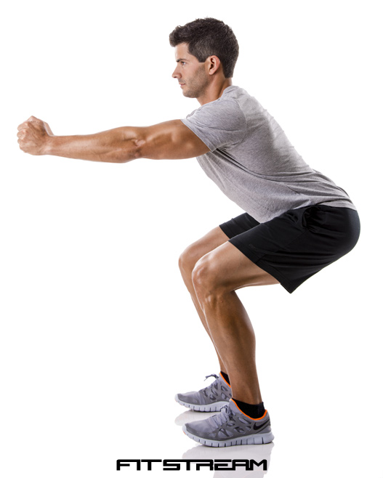

Leg Raises

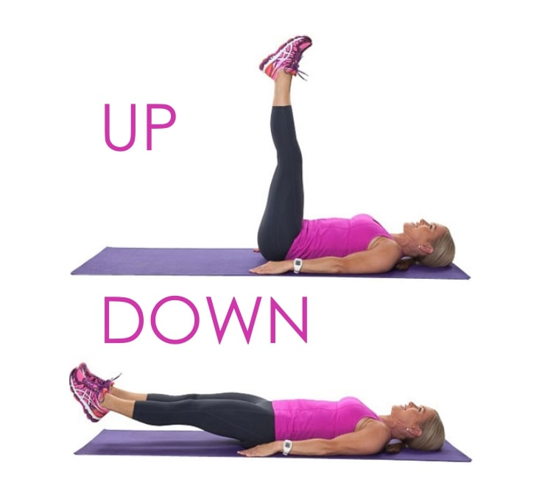

Lunges

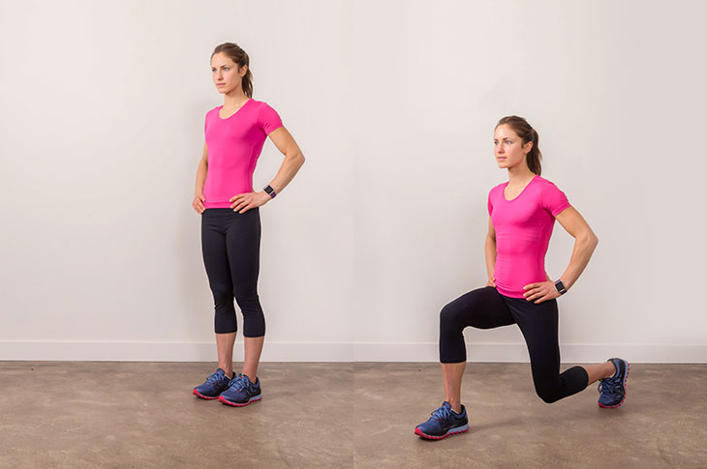

Partner Sit Ups with ball (If perfroming individually, normal sit ups)

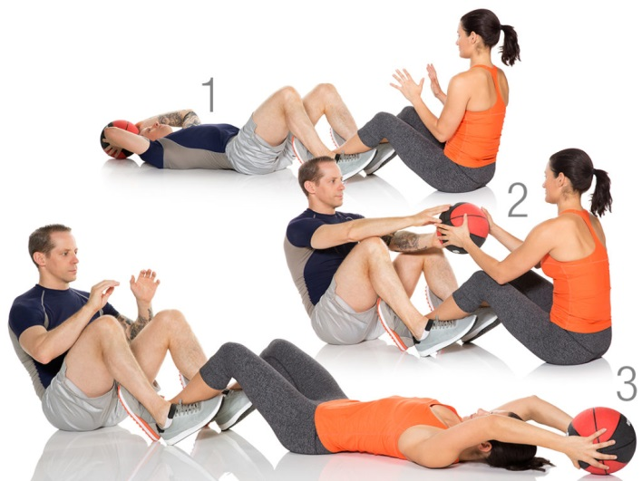

Press Ups

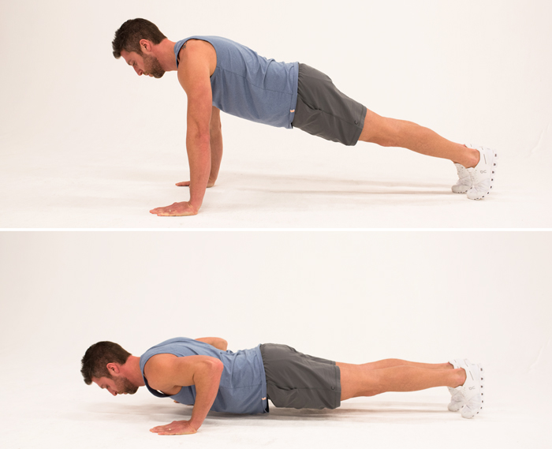

Speed Bounce
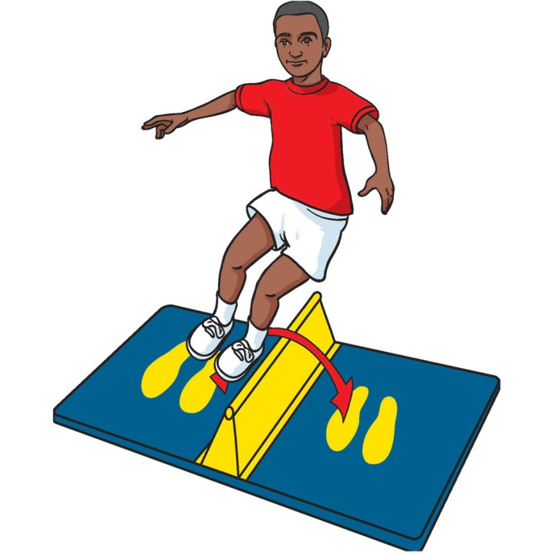


Going for Gold Fitness Challenge Names:

 | Attempt 1 | Attempt 2 | Attempt 3 | Attempt 4
Burpees
Squats
Leg Raises
Lunges (Alternating legs)
Ab ball (Pass ball over to partner)
Press Ups
Speed Bounce

Going for Gold Fitness Challenge Names:

 | Attempt 1 | Attempt 2 | Attempt 3 | Attempt 4
Burpees
Squats
Leg Raises
Lunges (Alternating legs)
Ab ball (Pass ball over to partner)
Press Ups
Speed Bounce

Feelings? Thoughts? Did it go well? What values did you use when working together on this challenge? Did you try your hardest? How did it make you feel?
Burpees
Squats
Leg Raises
Lunges
Ab Ball
Press Ups
Speed Bounce

Take a photo

Congratulations!
You have completed the Prostars Weekend Physical Activity planner 2!
We would love to hear what you thought of our planner so please if you can leave us a review on our Facebook page! (Search ‘Prostars’ to find us).
Can we take this opportunity to say a huge thank you from all of us at Prostars, it has been great to be on this journey with you and we hope you continue to lead a healthy lifestyle and stay active!
If you want to get in contact please email us at
Jfowler.prostars.fse@gmail.com

Jcarter.fse@gmail.com

